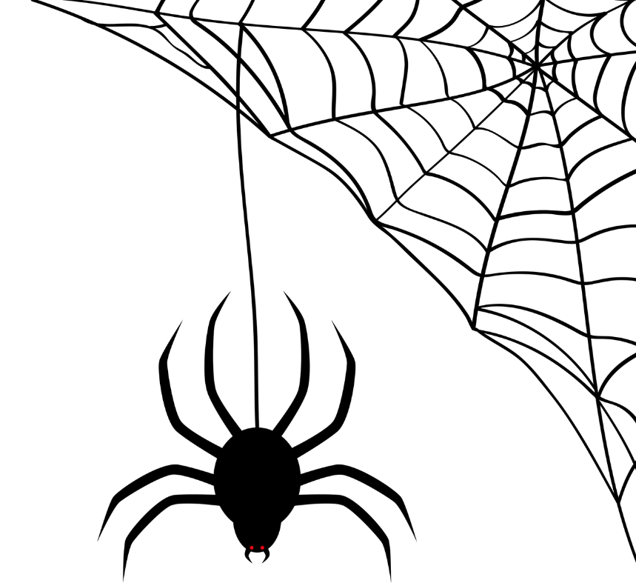
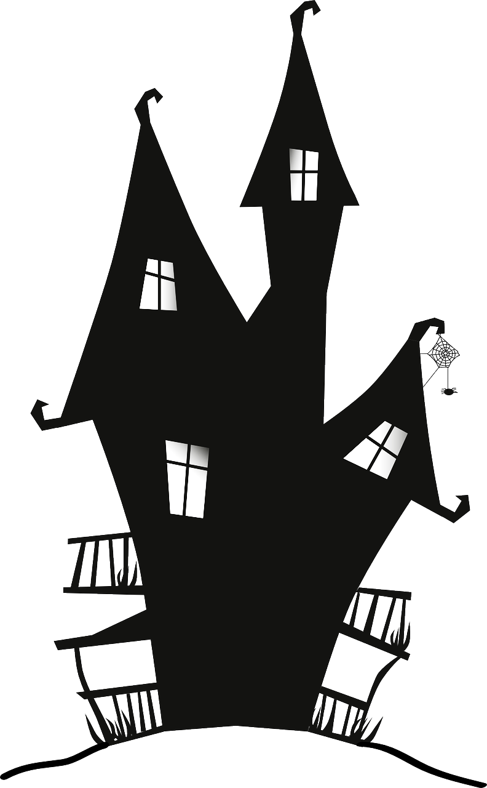

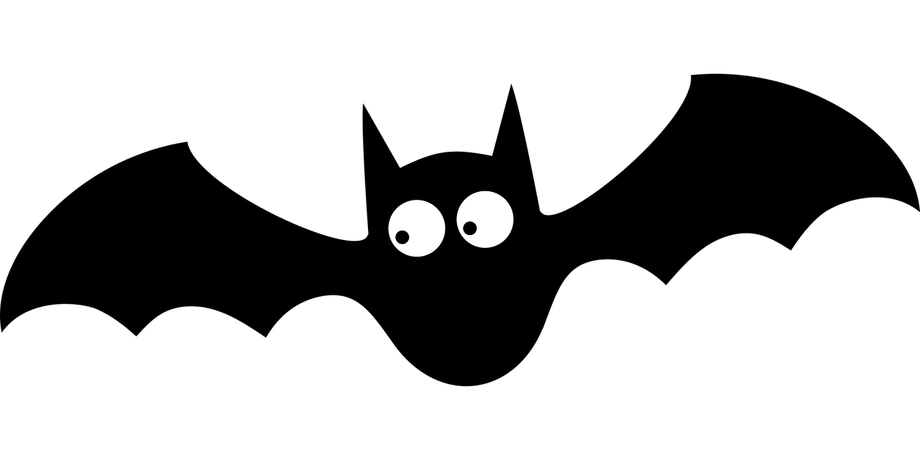
Get ready for a super scary

HALLOWEEN

Dance
Saturday, Nov 1, 2025
Ripley Co Fairgrounds

Music by Dusty Rangers
From 7pm – 12am
Costume contest at 10pm
$5 per person cover charge
Food AvailableBYOBCamping Available
Call 812-689-6535 for reservations or more info

